**UNIVERSITY REGISTER OFFICE:**

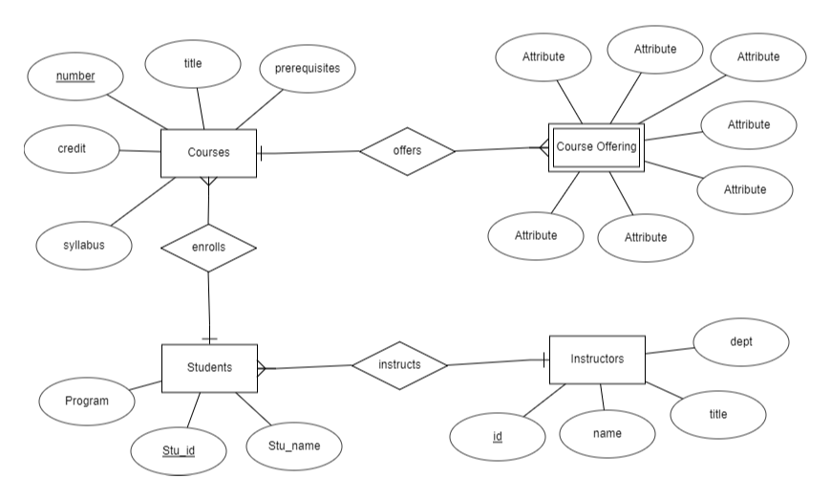

In this ER diagram we can infer that Instructor instructs the students and the student takes up the courses and the course offers the course offering.

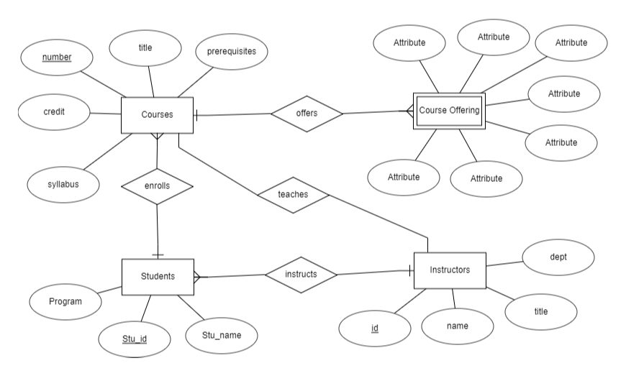

From this ER diagram we can infer that instructor instructs students , instructor alse teaches courses

So that student enrolls courses and course offers course offering